**COMP 3710 Applied Artificial Intelligence**

**Seminar/Lab 11.**

**Uncertainty in Environments**

1. Objectives

* Use of conditional probabilities
* Use of joint probability distributions
* Use of conditional independence

1. Use the following probabilities to calculate *P*(*a* ∧ *b*), *P*(*b* | *a*) and *P*(¬*b* | *a*). (You need to show how to calculate.)

*P*(*a*) = 0.04

*P*(*b*) = 0.05

*P*(*a* | *b*) = 0.6

*P*(*a* | ¬*b*) = 1 / 95

1. Find the followings from the next joint probability distribution. (You need to show how to calculate.)

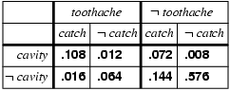

* 1. 

1. Find the followings from the next probabilities. (You need to show how to calculate.)

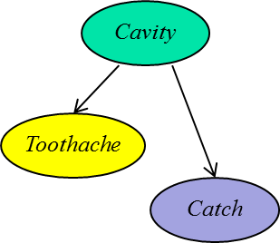*P*(*cavity*) = 0.2

*P*(*catch* | *cavity*) = 0.9

*P*(*catch* | ~*cavity*) = 0.2

*P*(*toothache* | *cavity*) = 0.6

*P*(*toothache* | ~*cavity*) = 0.1

1. *P*(*toothache*)
2. *P*(*catch*)
3. *P*(*cavity* | *toothache*)
4. *P*(*cavity* | *catch*)
5. After your yearly checkup, the doctor has bad news and good news. The bad news is that you tested positive for a serious disease and that the test is 99% accurate (i.e., the probability of testing positive when you do have the disease is .99,) as is the probability of testing negative when you don’t have the disease. The good news is that this is a rare disease, striking only 1 in 10,000 people of your age.
   1. What are the chances that you actually have the disease? You should think what kind of probability you need to obtain. (You need to show how to calculate.)

Hint: *P*(+) = *P*(+ ∧ *D*) + *P*(+ ∧ ~*D*); *P*(+ ∧ ~*D*) = *P*(*~D*) – *P*(− ∧ ~*D*)

1. Submission

* Total marks: 10 (= 2 + 1 + 4 + 3)
* Due: 6:00 PM, November 27, 2017
* No late submission is accepted.
* Note: You should use a word processor, not hand writing.